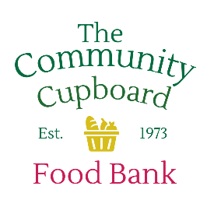
The Community Cupboard - Prescott Valley Location
8671 E. Spouse Drive, Prescott Valley, AZ 86314 (928) 772-4490

Our mission is to serve individuals and families who are experiencing food insecurity in the surrounding areas.

Volunteers are needed every day to help pack donated and bulk foods, and assemble bags for individuals and special programs, provide administrative support, and assist during special events.

Volunteers greet clients; enter their visit to our computer and assist them in choosing the food they need. We provide food based on the number of people in their family. We select the food they have chosen, bag it for them and help the client to their car when necessary.

Volunteers also stock the shelves with the available inventory when not assisting clients.

We also accept food and monetary donations. The Food is weighed, the donor and number of pounds of food is notated on the log in a binder. We also check expiration dates of the donated food to make sure the items are still viable. When cash or checks are donated the donor’s name, date, check number and amount are noted on the log in a binder. The cash/check is then put in Annmarie’s folder.

At the end of the day, the tables are wiped down, trash emptied, refrigerator and freezer temperatures are logged, and the food bank is left an orderly manner.

Contact Ruth Carson, Volunteer Coordinator, to volunteer or if you need more information at mikrufis@aol.com or call 928-772-4490.

